How to spawn platform using the two Key.

1. Create a new unity project.

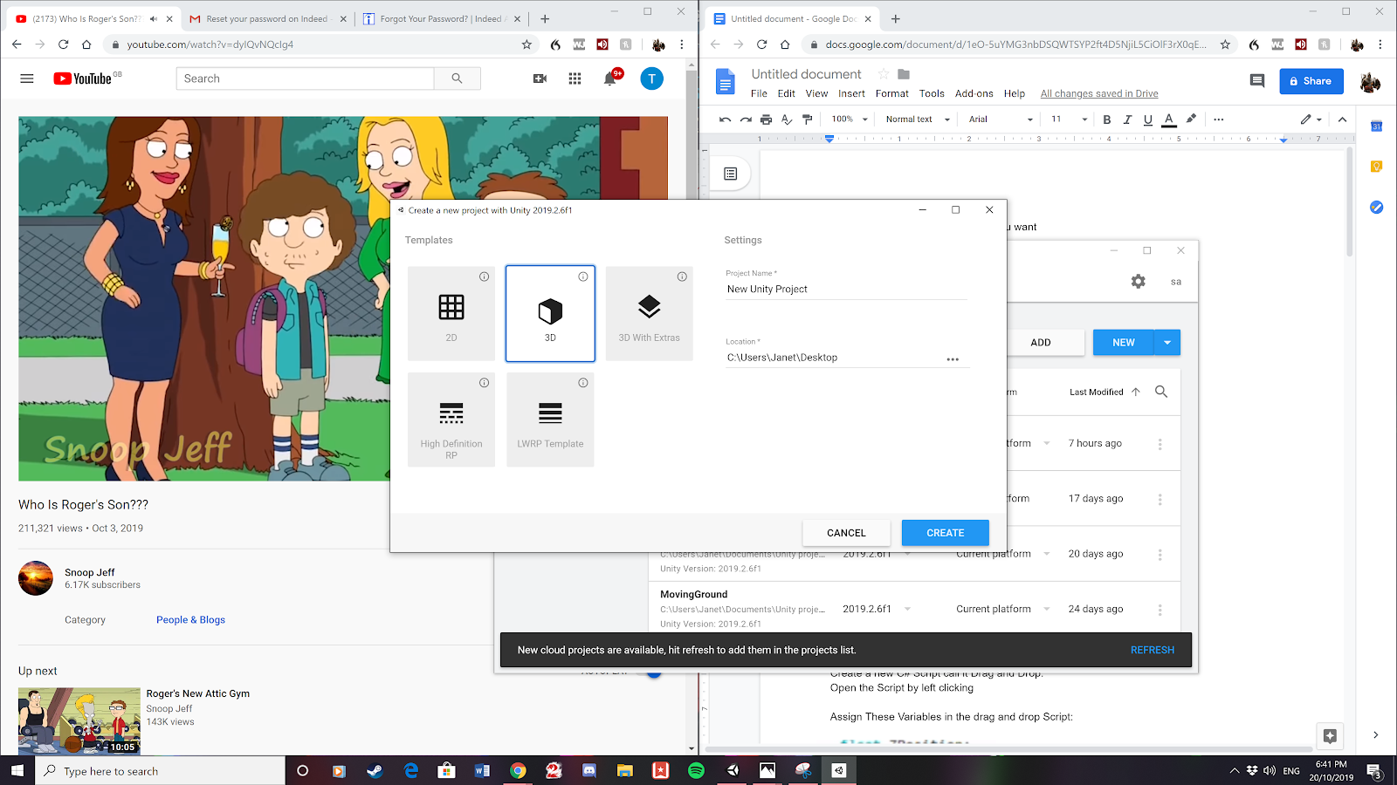

1. Create three cubes. By left clicking on the hierarchy and selecting 3d objects and clicking on. Do this 3 times

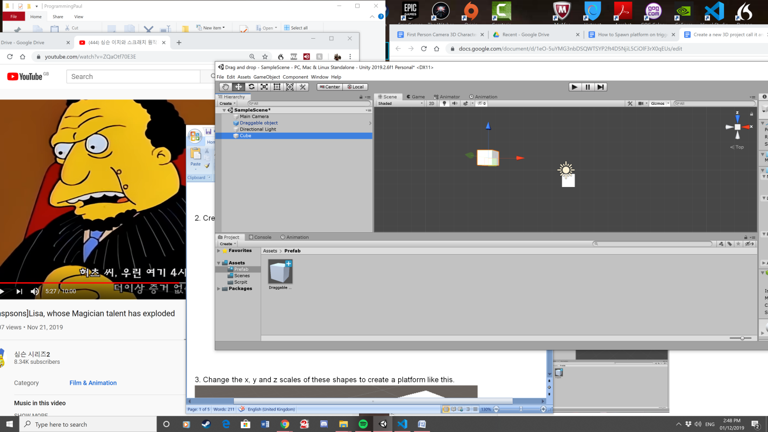

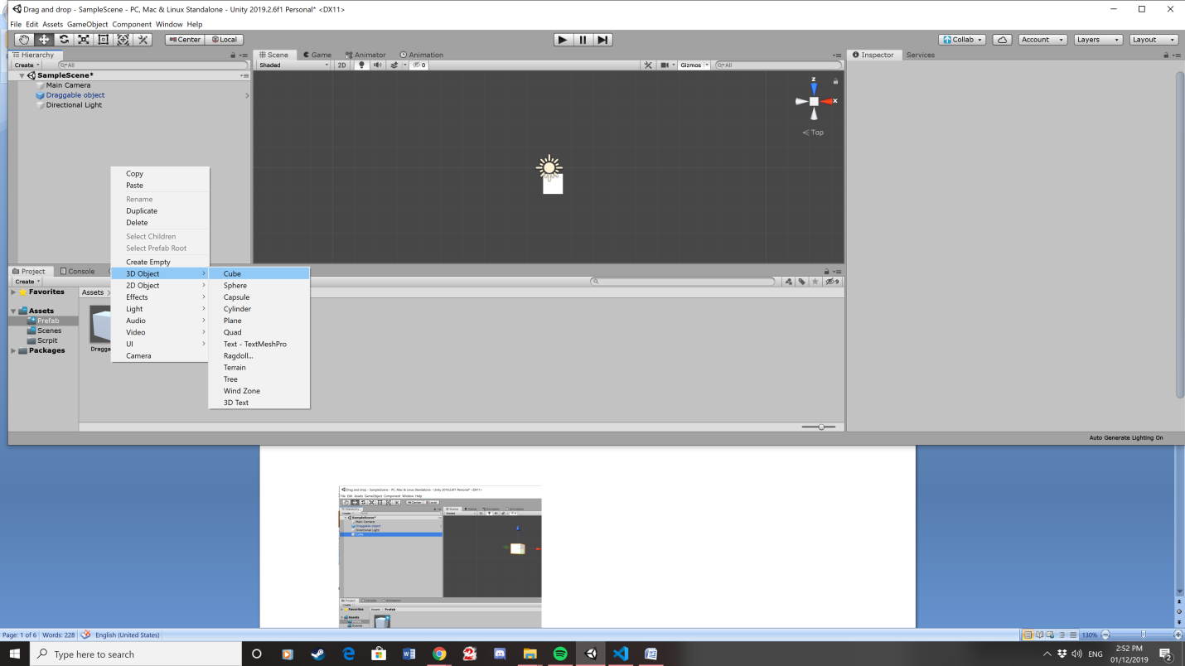

3. Change the x, y and z scales of these shapes to create a platform like this.

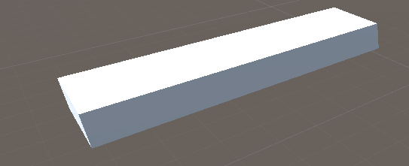

4. To change these scales we need to use the scale tool. This is found on the menu at the top of unity.

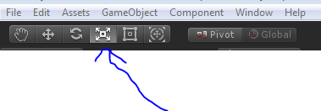

. 5. Put all the platforms you made together like this.

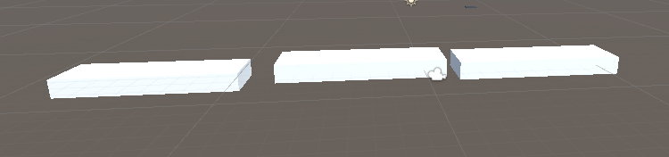

6. Then we will disable the middle platform by selecting the middle platform and unpicking this box in the inspector for the cube.

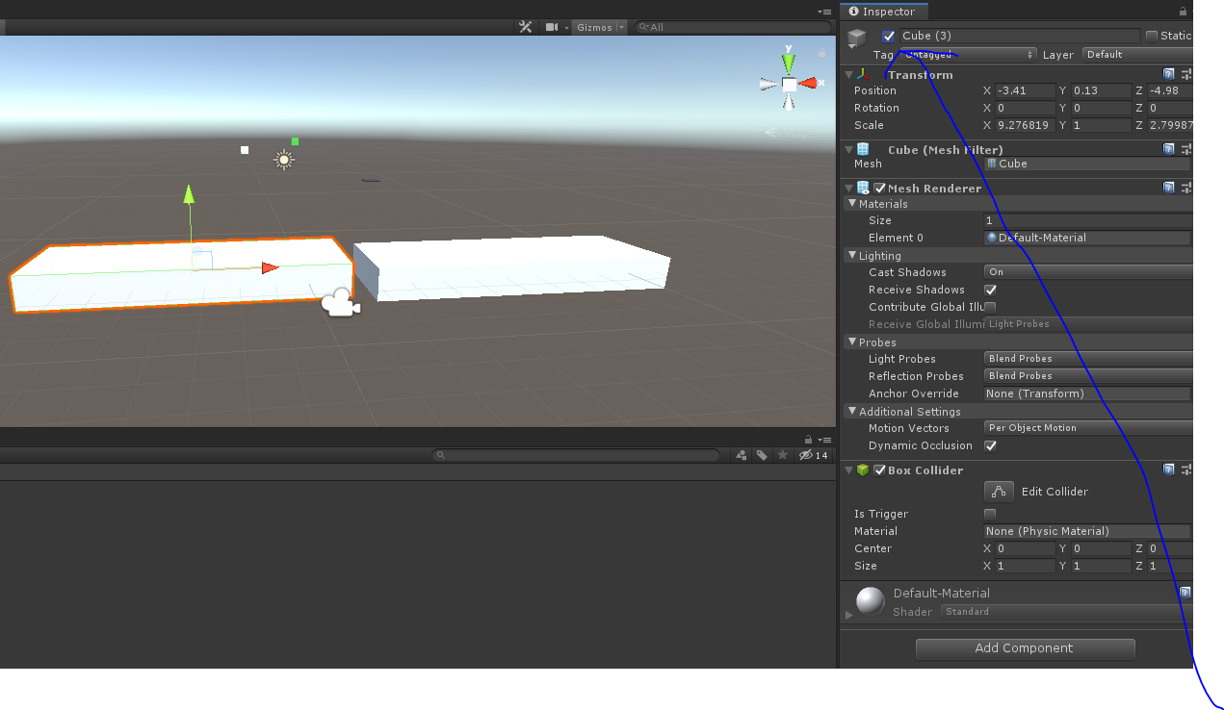

7. Add a box collider to this platform.

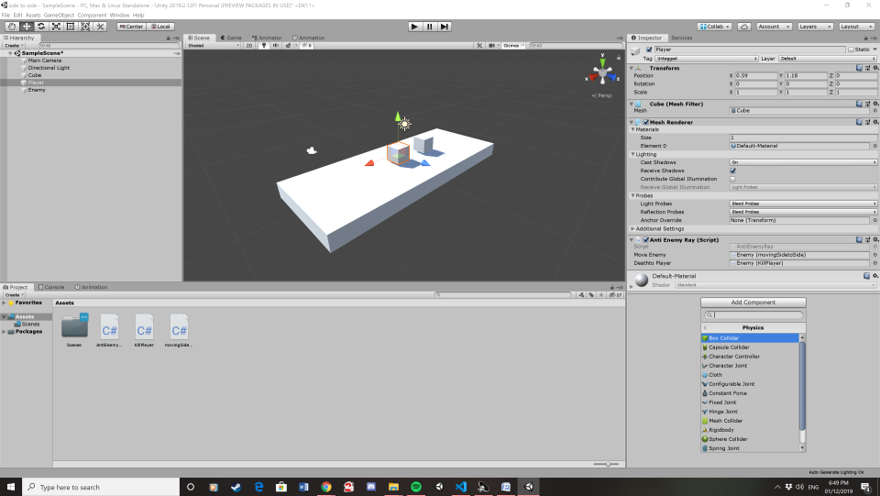

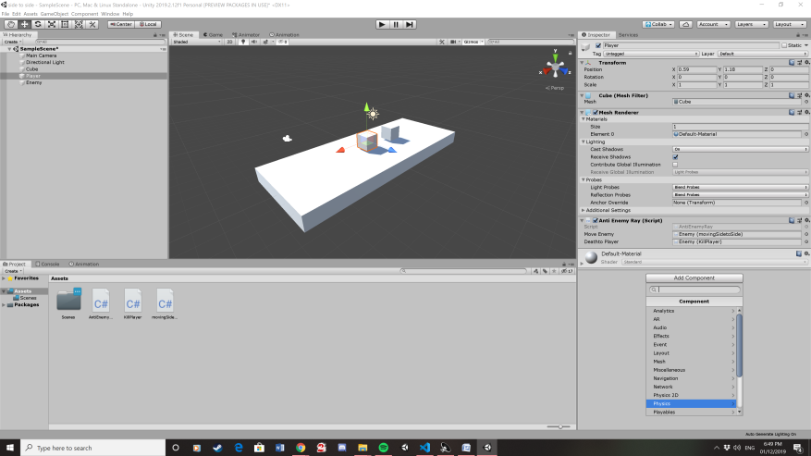

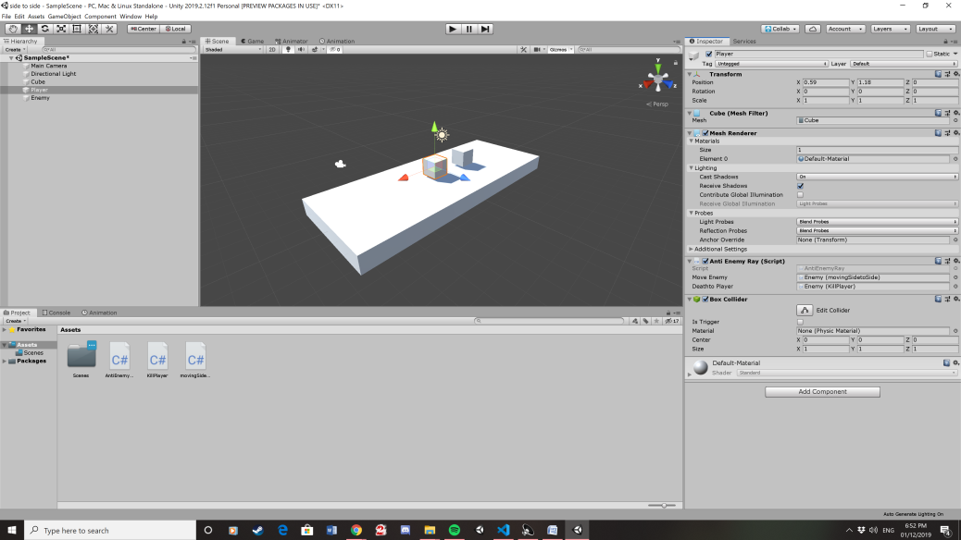

8. Create a cube for the player character.

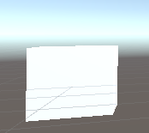

9. Create a material

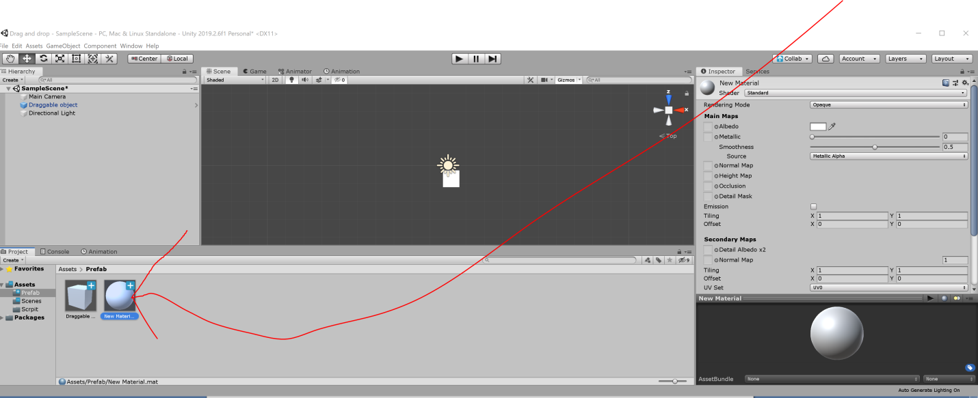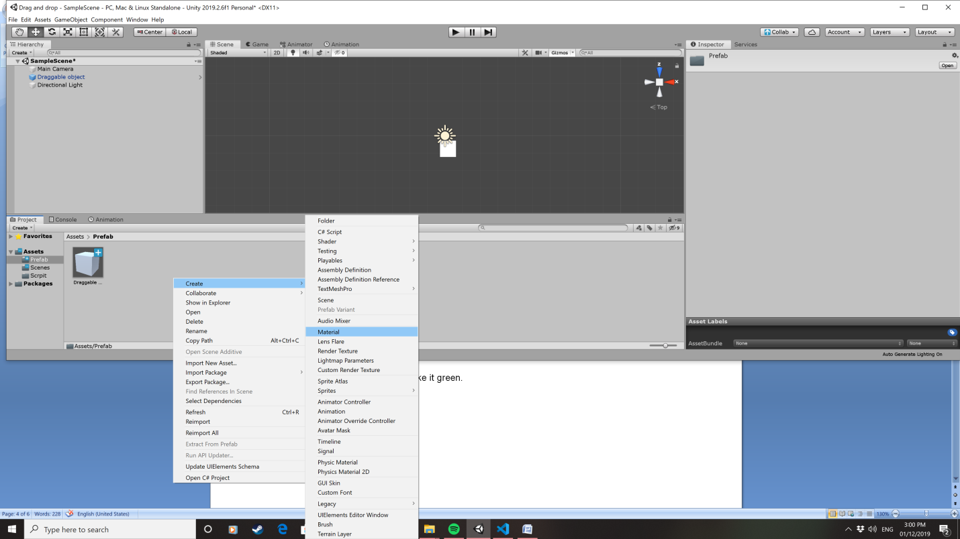

10. Then click on the material and change the Albedo to green.

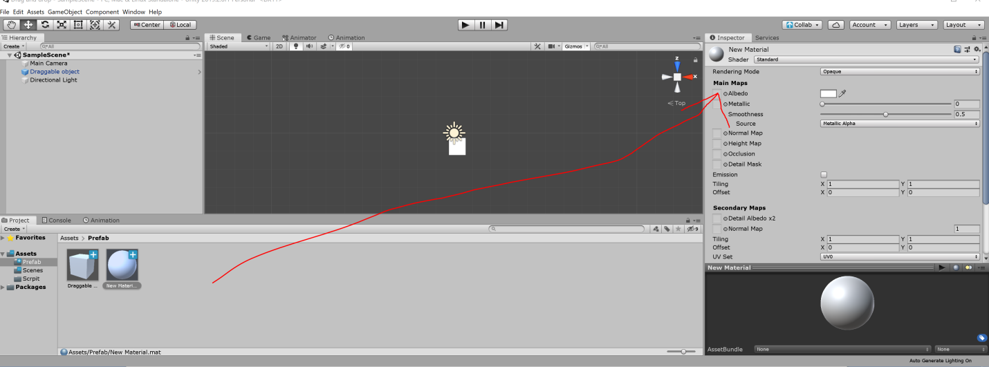

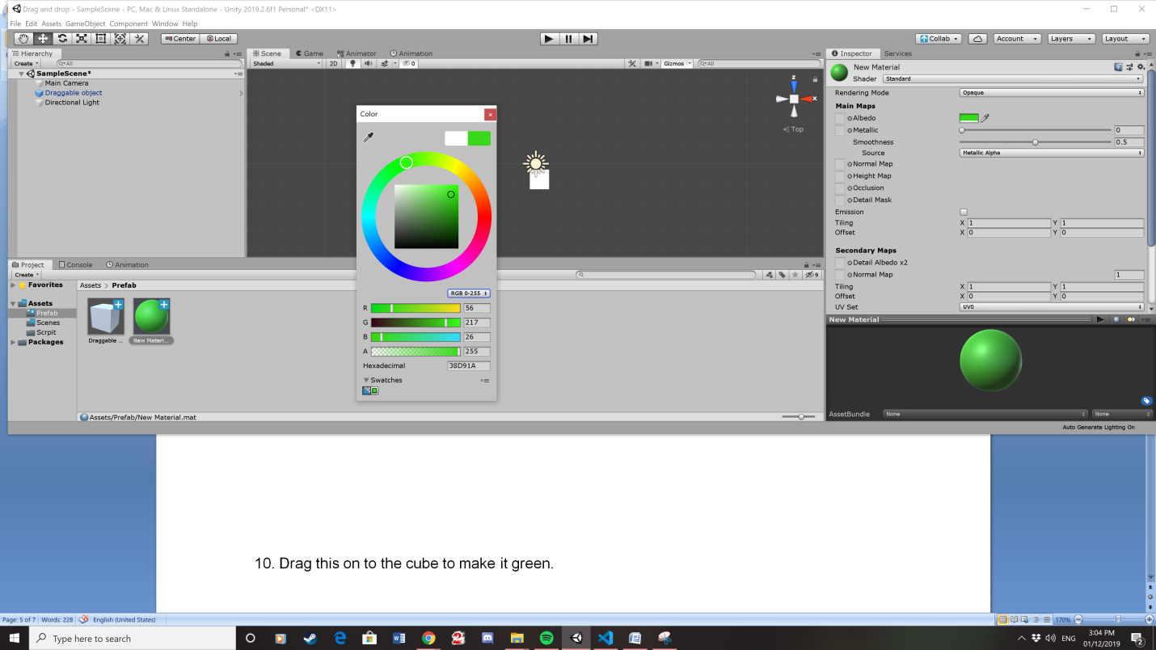

11. Drag this on to the cube to make it green.

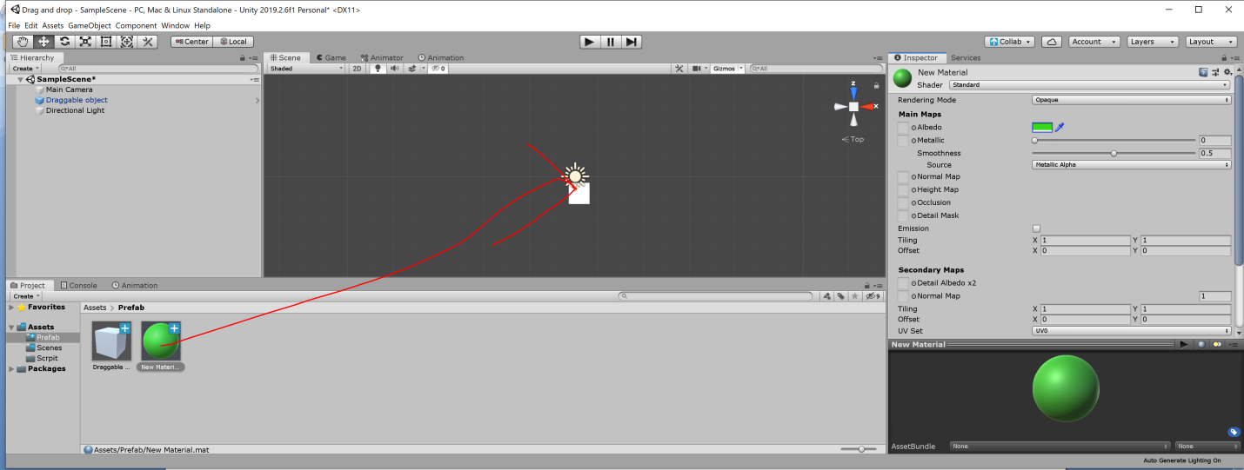

12. This is what the scene should look like

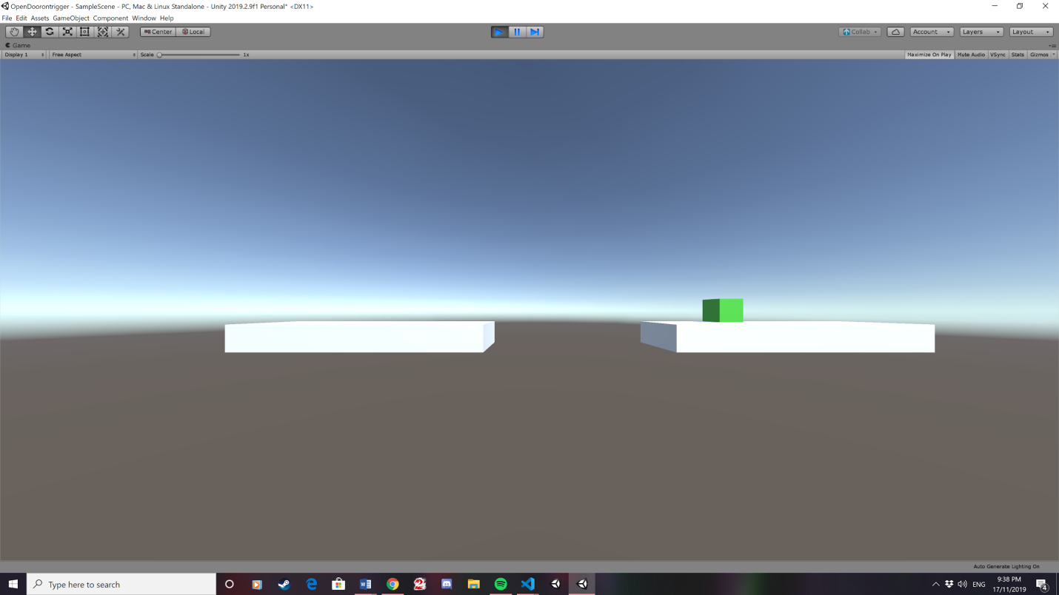

13. Create a new script.

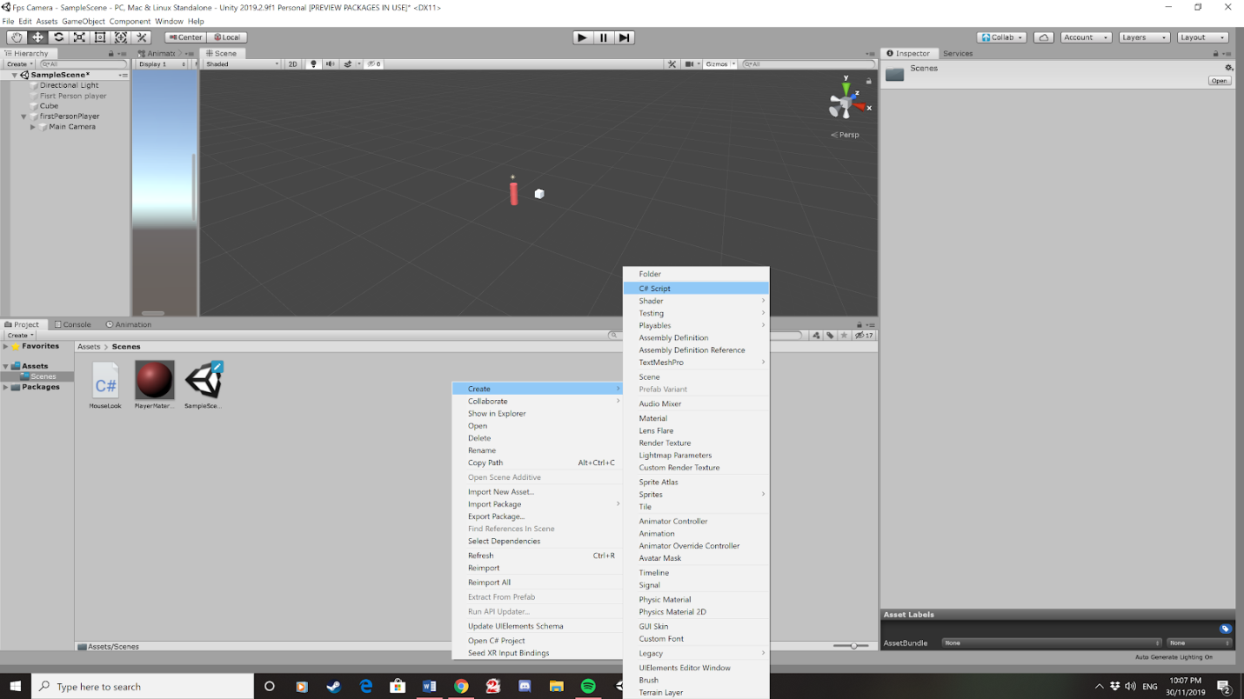

14. Call this Script power 2

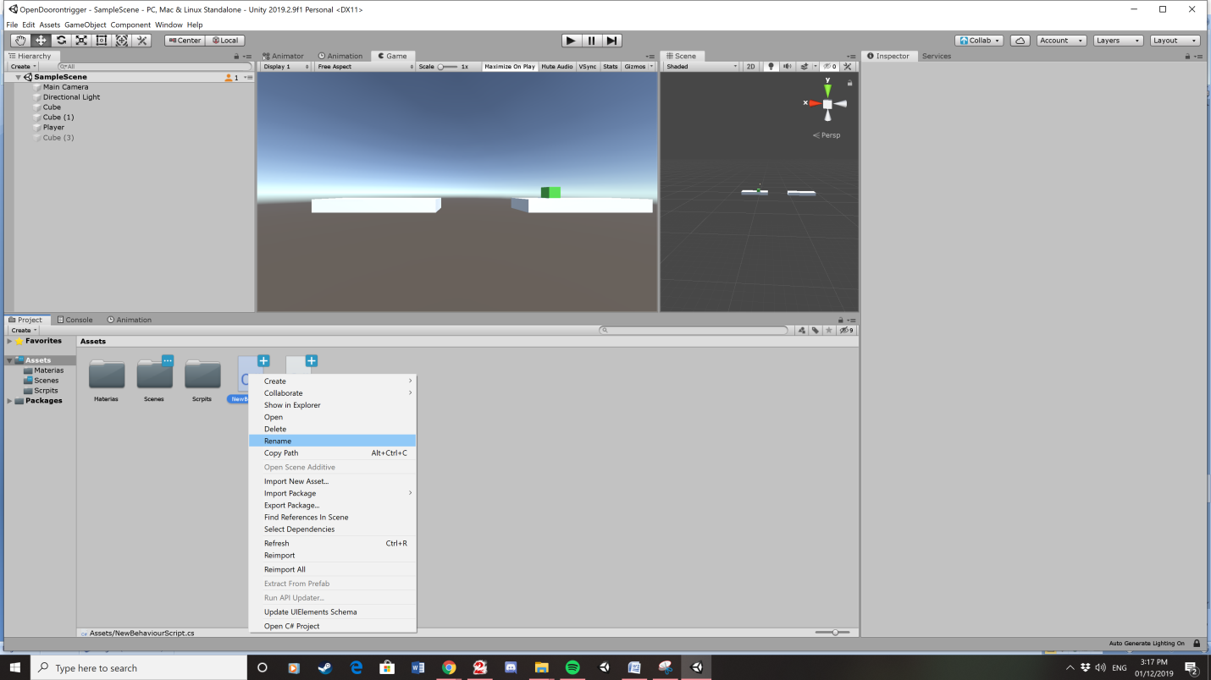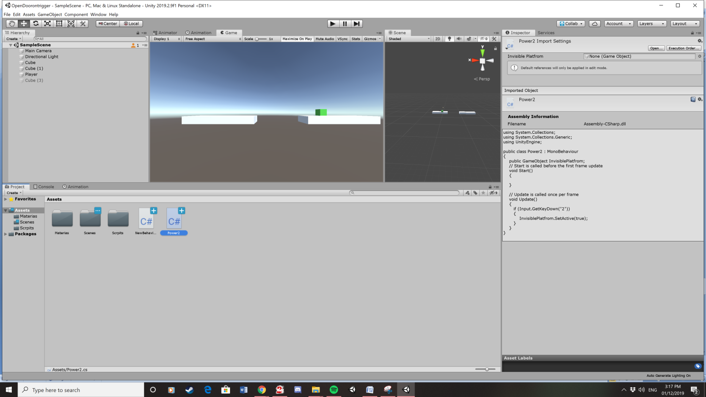

15. This script will allow the player to press to 2 to enable the disabled platform.

16. Drag this Script onto the player game object.

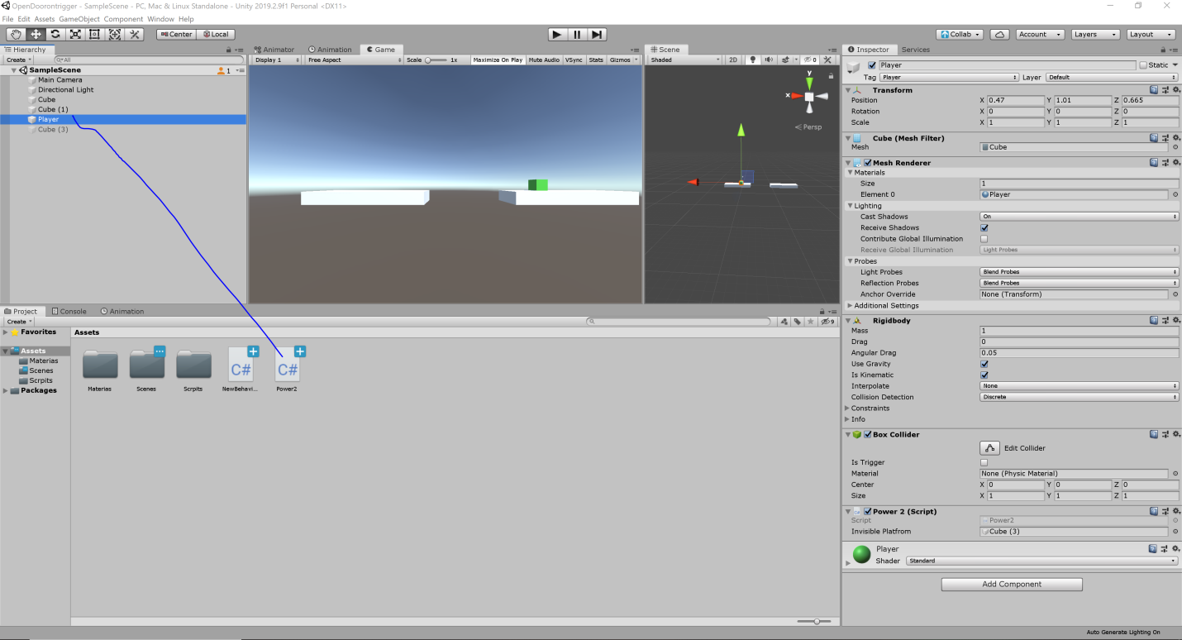

17. Then open the script by left clicking on it which opens visual studio code.

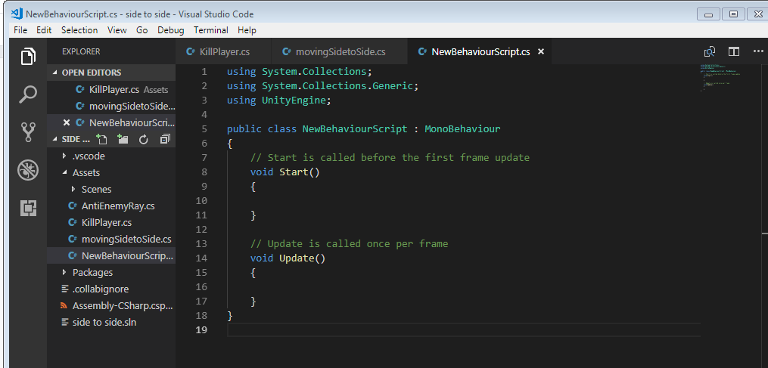

18. Here it is: you will need to copy all this code expect public class power 2.

using System.Collections;

using System.Collections.Generic;

using UnityEngine;

public class Power2 : MonoBehaviour

{

public GameObject InvisiblePlatfrom;

// Start is called before the first frame update

void Start()

{

}

// Update is called once per frame

void Update()

{

if (Input.GetKeyDown("2"))

{

InvisiblePlatfrom.SetActive(true);

}

}

}

19. Then drag the invisible platform onto power 2.

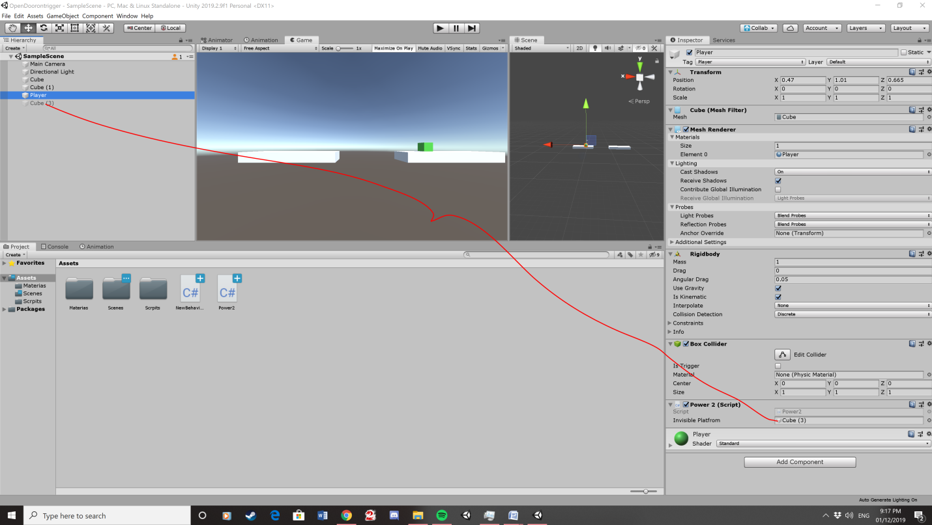

20. Then press the play button to get the program to work. 